**Title: Automatic Number Plate Recognition**

1. **Introduction**

Automatic Number Plate Recognition (ANPR) is a computer vision task that localizes and extracts vehicle registration plates from images or video to enable applications such as traffic surveillance, law enforcement, tolling, parking management, and access control. In India, ANPR systems face practical challenges including non‑standard plate sizes and fonts, motorcycle plates with rounded corners, screws and stickers that occlude characters, harsh sunlight and shadows, reflective chrome and indicators, and cluttered backgrounds like tiled roads. This project develops an explainable, training‑free pipeline that detects and rectifies number plates from single images while exposing intermediate steps for transparency and tuning.

**1.1 Problem statement**

* Build a robust plate localization system that works on varied Indian vehicle photos, especially motorcycles with rounded plates.
* Minimize false positives from floor tiles, chrome exhausts, and indicator lamps.
* Deliver a rectified plate crop suitable for OCR while keeping the pipeline fully classical and interpretable.

**1.2 Objectives**

* Design a stepwise detection pipeline using illumination correction, stroke emphasis, ROI gating, morphology, and geometric/photometric checks.
* Visualize each stage (enhancement, edges, bands, contours, candidates, final warp) to aid understanding and debugging.
* Provide compact, reproducible code for each foundational operation and the final detector.

**1.3 Scope and assumptions**

* Single‑image plate localization and rectification (not full OCR).
* Outdoor images with common smartphone camera settings; moderate perspective and lighting variation.
* Emphasis on classical image processing over machine learning to remain training‑free and highly explainable.

**1.4 Contributions**

* A “bright slab + dark stroke” fusion that combines top‑hat/CLAHE, vertical gradients, and Canny edges under a plate‑shaped brightness mask.
* Tail‑zone ROI gating for motorcycles to suppress floor and lamp clutter before contouring.
* Lightweight text‑band verification using vertical/horizontal projections to distinguish plates from bright rectangles without characters.
* A consistent visualization and reporting framework that demonstrates basic operations, frequency/spatial filtering, and the final detection pipeline.

**1.5 Tech stack (overview)**

* Language: Python 3.x
* Libraries: OpenCV for image operations and warping; NumPy for array math; Matplotlib for inline figures.
* Rationale: CPU‑friendly, portable, and fully explainable classical vision components with strong community support.

**1.6 Method summary**

* Preprocess: resize, grayscale, bilateral filter, top‑hat illumination correction, CLAHE contrast boosting.
* Plate mask: adaptive + Otsu thresholding, morphology, and ROI gating to isolate a bright plate “slab.”
* Stroke emphasis: Sobel‑X plus Canny fused and masked; HSV suppression for orange indicators.
* Band formation: horizontal closing to connect characters into plate bands; contour extraction and cleaning.
* Candidate scoring: aspect/area/width gates, white‑fraction and edge‑density checks, text‑band metrics, spatial prior, rectangularity; choose best.
* Rectification: perspective warp to a canonical plate patch for downstream OCR or analysis.

**1.7 Expected outcomes**

* Reliable plate localization on diverse Indian motorcycle/car images, with interpretable intermediate outputs.
* A rectified, fixed‑size plate crop ready for OCR.
* A report that documents each foundational operation, the complete pipeline, and tuning guidance for new datasets.

1. **Image Processing Techniques**

*This section summarizes some of the core operations used to manipulate, enhance, and analyse digital images prior to high‑level tasks like detection and recognition. The methods below fall into a few broad categories and are chosen to improve visibility of meaningful structure (edges, text strokes) while suppressing nuisance factors (noise, glare, background clutter).*

**Arithmetic operations**

Concept

* Point operations that transform pixel intensities independently at each location. Operate on a single image with a scalar or on two images of identical size, pixel‑by‑pixel. Values are clipped to 0–255 (8‑bit) unless working in float and normalized later.

Code:

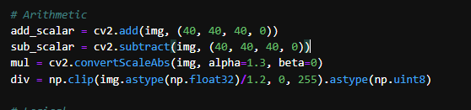

* 1. **Addition (brightness increase)**
* What: Adds a constant k(in my given example K is taken as 40)or adds two images I1 + I2.
* Math: p' = p + k or p' = p1 + p2; clamp to .
* Use: Brighten underexposed images; blend two aligned images; add small bias before logarithms.
* Pitfalls: Saturation when highlights exceed 255; may wash out contrast if k is too large.
* In this project: Quick exposure nudges to evaluate plate visibility before edge formation.

Output:

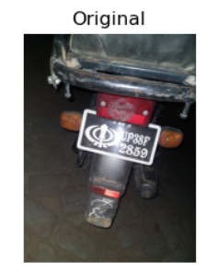 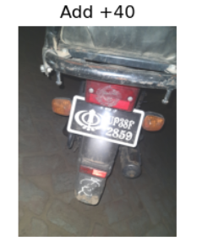

* 1. **Subtraction (brightness decrease / change detection)**
* What: Subtract a constant or subtract two aligned images.
* Math: p' = p − k or p' = p1 − p2 (often |p1 − p2|).
* Use: Illumination balancing, background removal, motion/change detection across frames.
* Pitfalls: Underflow to 0; not robust if the two images are not registered.
* In this project: Helpful to visualize shading bias on the plate slab.

Output:

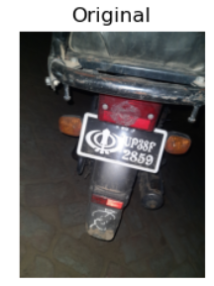 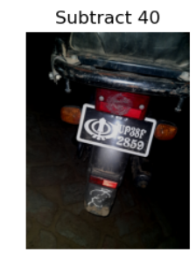

* 1. **Multiplication (contrast gain)**
* What: Scales intensity by a gain α (α>1 increases contrast; α<1 reduces).
* Math: p' = α·p; clamp to .
* Use: Global contrast scaling; simple “contrast stretch” without breakpoints.
* Pitfalls: Quickly saturates highlights; may amplify sensor noise in shadows.
* In this project: Examining how stronger edges appear before Sobel/Canny.

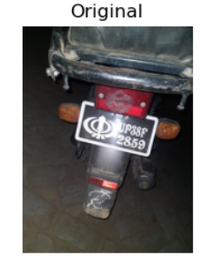 Output

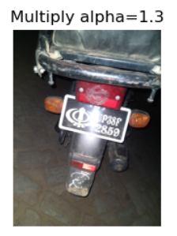

* 1. **Division (attenuation / shading correction)**
* What: Scales intensity inversely; also I1/I2 for shading field correction if I2 is a smooth illumination map.
* Math: p' = p / γ (scalar) or p' = p1 / (p2 + ε) (image division).
* Use: Vignetting/shading compensation; flatten non‑uniform illumination.
* Pitfalls: Division by near‑zero; must use float and add ε; can amplify noise.
* In this project: Inspired the top‑hat step that flattens illumination.

Output:

 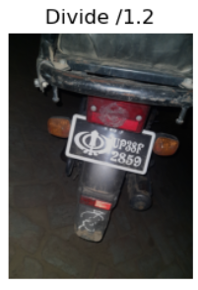

* 1. **Weighted sum / blending (addWeighted)**
* What: Linear combination of two images.
* Math: p' = α·A + β·B + γ; often α+β=1, γ=0.
* Use: Smoothing while preserving detail (blend with blur); cross‑fading.
* Pitfalls: Ghosting if inputs are not aligned; contrast loss if weights are not balanced.
* In this project: Quick way to show a “mildly denoised” version for edge stability.

Output:

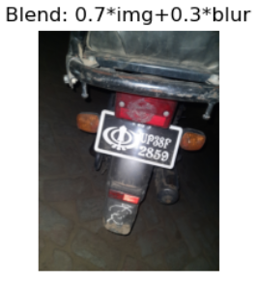

**Logical operations**

Concept

* Binary image logic (AND, OR, XOR, NOT) and masking of grayscale/color by single‑channel masks.

Code:

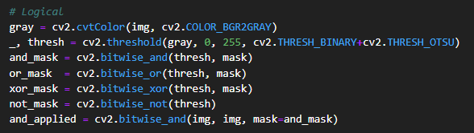

Synthetic Mask Used:



1. AND (intersection)

* What: Keeps pixels that are 1 in both masks.
* Use: Enforce multiple conditions simultaneously (e.g., edges AND bright‑slab).
* Pitfalls: Over‑restrictive masks can accidentally remove target regions.
* In this project: Retained only edges lying on the bright plate slab.

Output:

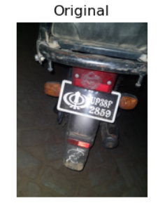 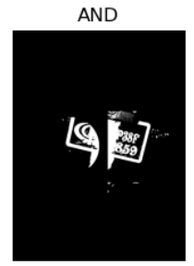

1. OR (union)

* What: Keeps pixels that are 1 in either mask.
* Use: Merge proposals or multiple detectors.
* Pitfalls: Noisy if masks are generous; follow with morphology if needed.

Output:

 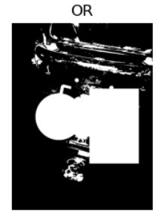

1. XOR (exclusive difference)

* What: Keeps pixels that differ between masks.
* Use: Highlight disagreement/change detection; diagnostics.

Output:

 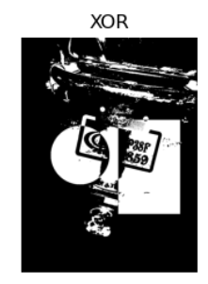

1. NOT (inversion)

* What: Flips 0↔1 or 0↔255.
* Use: Prepare “foreground strokes” from a white background after thresholding.

Output:

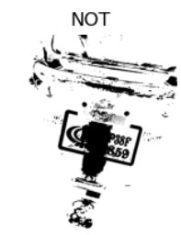

**Logarithmic, inverse‑log, exponential transforms**

Concept

* Nonlinear intensity mappings to redistribute dynamic range.

Code:

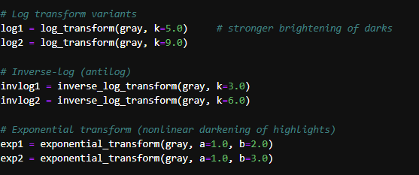

1. Log transform

* Math: g = log(1 + k·f), with f∈, then normalize to 8‑bit.
* Effect: Expands darks, compresses brights; reveals shadow details.
* Use: Prep step when characters are underexposed; pre‑Canny stabilization.
* Pitfalls: Highlights can lose contrast; choose k to avoid over‑flattening.

Output:

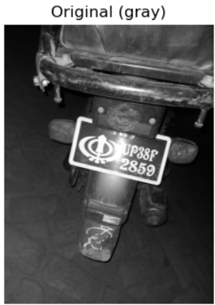 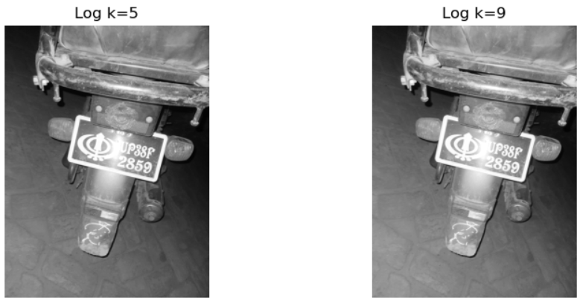

1. Inverse‑log (antilog)

* Math: g = (exp(c·f) − 1)/k, rescaled to 8‑bit.
* Effect: Emphasizes bright tones; de‑emphasizes darks.
* Use: If the interesting content is bright on dark (less common for plates).

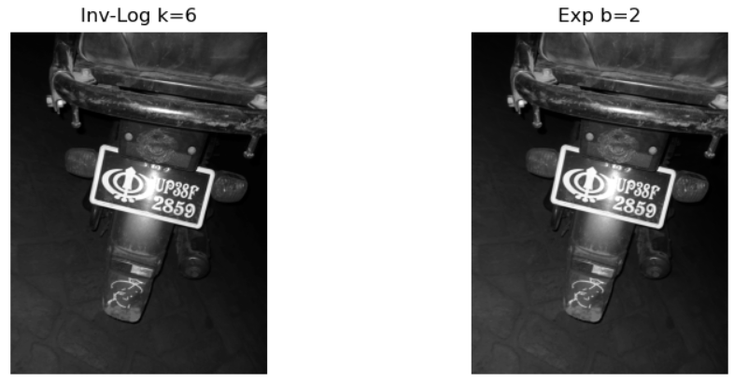Output:



1. Exponential / gamma‑like mapping

* Math: g = b^f − 1 or g = f^γ; γ<1 brightens shadows.
* Use: Controlled brightening of mid‑tones; gentle alternative to log.
* Pitfalls: Banding if not normalized; noise boost in shadows.

Output:

 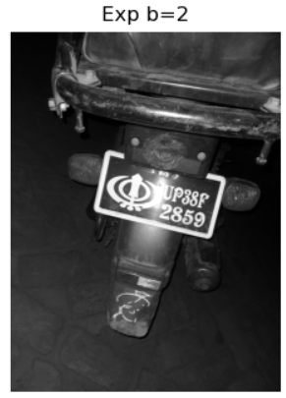 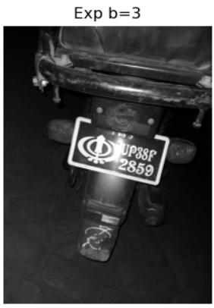

**Piecewise intensity transforms**

1. Contrast stretching (three‑segment piecewise linear)

* Math: Map [0,r1]→[0,s1], [r1,r2]→[s1,s2], [r2,255]→[s2,255].
* Effect: Expands contrast in targeted ranges; preserves monotonicity.
* Use: Lift mid‑tones (characters) without clipping whites.
* Pitfalls: Wrong breakpoints produce harsh steps; prefer small, measured changes.

Code:

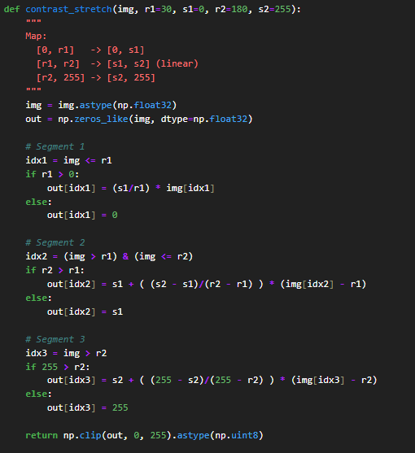

Output

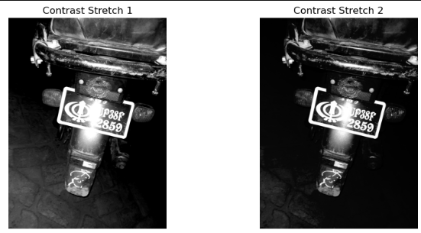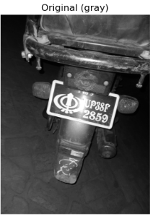

1. Gray‑level slicing

* Math: If a ≤ p ≤ b, set high; else keep or set low.
* Effect: Highlights a narrow intensity band.
* Use: Emphasize plate digits or reflective bolts for visualization/teaching.
* Pitfalls: Sensitive to threshold selection; not robust to global illumination changes.

Code:

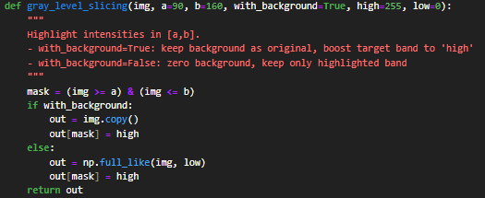

Output:

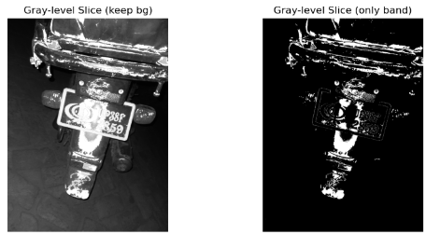

1. Bit‑plane slicing

* Math: plane k = (img >> k) & 1.
* Effect: MSBs show structure; LSBs show fine detail/noise.
* Use: Educational diagnostics; motivates why thresholding avoids LSB noise.

Code:

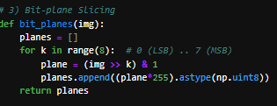

Output:

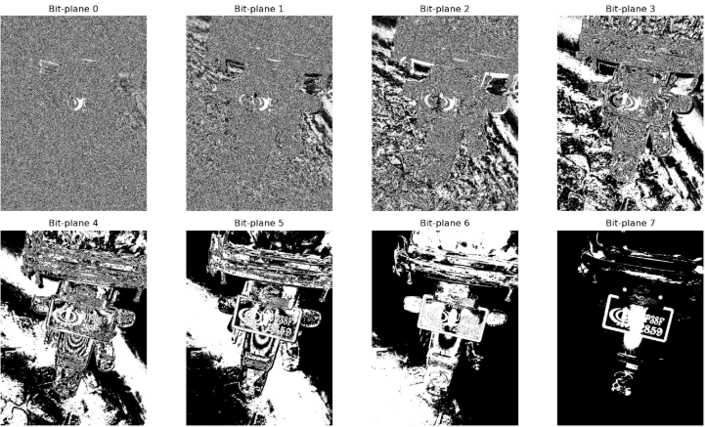

**Spatial filtering (smoothing)**

Code:

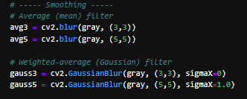

1. Average (mean) filter

* Math: Convolution with uniform kernel K = (1/N)·1.
* Effect: Reduces noise; blurs edges.
* Use: Pre‑denoise before Canny/thresholds when noise is strong.
* Pitfalls: Edge details (digits) soften quickly; prefer small kernels (3×3, 5×5).

Output:

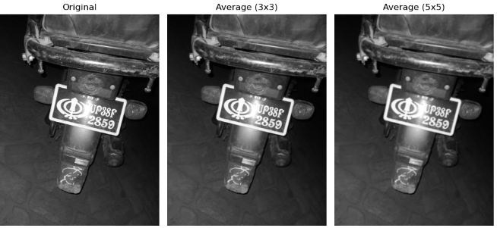

1. Gaussian filter (weighted average)

* Math: Convolution with discrete Gaussian kernel; separable in x,y.
* Effect: Smoothes with less edge distortion than mean.
* Use: Preferred pre‑smoother before gradient edges; reduces spurious Canny responses.
* Pitfalls: Over‑smoothing if σ too large; keep σ small for character strokes.

Output:

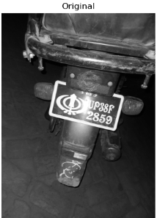 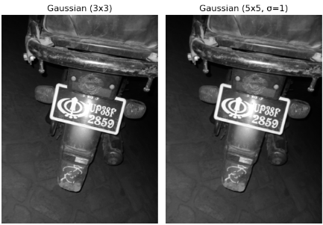

**Spatial filtering (sharpening)**

1. Roberts (2×2)

* Math: Diagonal gradients; sensitive to noise.
* Effect: Very fine edges; useful for high‑frequency inspection.
* Use: Educational; not commonly used alone in plate pipelines.

Code:

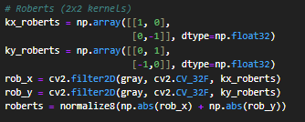

Output:

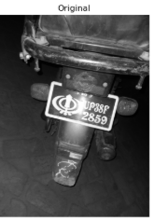 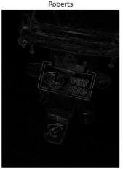

1. Prewitt (3×3) and Sobel (3×3)

* Math: First derivative in x/y; Sobel includes smoothing weights.
* Effect: Robust edge magnitude/orientation; thin edges after NMS.
* Use: Character stroke emphasis; feed into morphology.
* Pitfalls: Choose consistent scaling; combine |Gx|+|Gy| or magnitude.

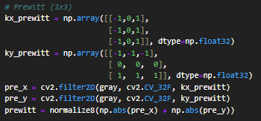Code:

Output:

 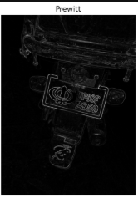

1. Laplacian (second derivative)

* Math: ∇²I via 3×3 or 5×5 kernels.
* Effect: Zero‑crossings at edges; highlights rapid changes.
* Use: Edge highlighting or unsharp masking (Laplacian added to original).
* Pitfalls: Very noise sensitive; blur first.

Code:

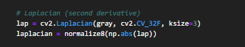

Output:

 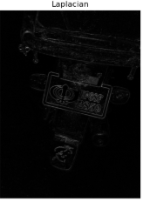

1. Sobel

* Math: First derivative in x/y with weighting that includes mild smoothing (central row/column weight 2).
* Effect: Robust gradient magnitude and orientation; cleaner edges than Prewitt at the same size.
* Use: Character‑stroke emphasis and pre‑Canny gradient; often compute |Gx|+|Gy| or √(Gx²+Gy²).
* Pitfalls: Still benefits from a small Gaussian blur first; keep kernel size 3 for thin text strokes.

Code:

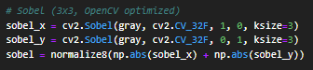

Output:

 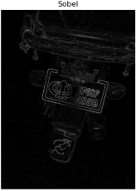

Canny edge detection

* Pipeline: Gaussian smoothing → gradient (Sobel) → non‑maximum suppression → double threshold → hysteresis linking.
* Parameters: lower/upper thresholds (e.g., 50/150, 100/200) or median‑based auto; aperture size (Sobel kernel).
* Strengths: Thin, connected edges; robust to noise compared to raw Sobel.
* Project use: Stable character edges feeding band connection and candidate ROI formation.
* Pitfalls: Over‑strict thresholds miss faint strokes; too soft creates clutter.

Code:

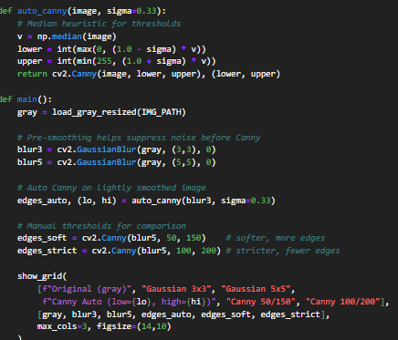

Output:

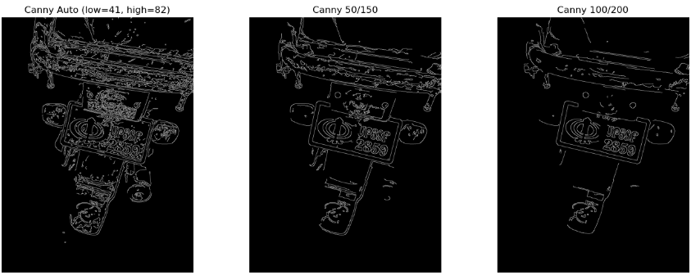

**Frequency‑domain filtering**

**Code:**

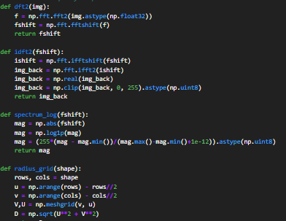

Low‑pass (smoothing)

Code:

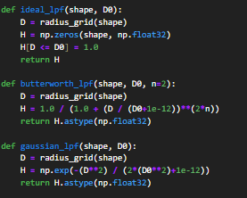

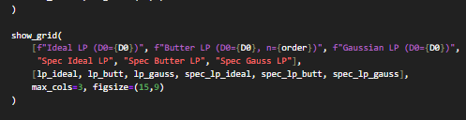

Original Images:

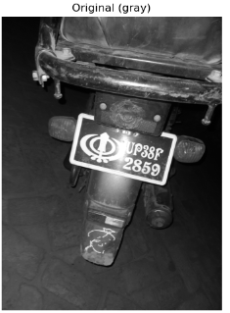 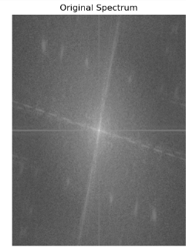

1. Ideal LPF

* Mask: Unity inside radius D0, zero outside.
* Effect: Strong blur; ringing near edges (Gibbs) due to abrupt cutoff.
* Use: Demonstration; rarely used in practice because of ringing.

Output

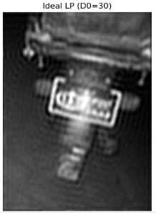

1. Butterworth LPF

* Mask: 1/(1+(D/D0)^(2n)); smooth roll‑off with order n.
* Effect: Controlled blur; less ringing than Ideal.
* Use: When smoother attenuation is needed without strong halos.

Output:

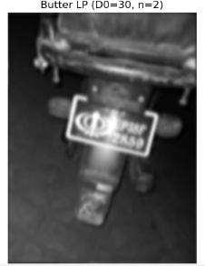

1. Gaussian LPF

* Mask: exp(−D²/(2D0²)); Gaussian in both domains.
* Effect: Natural blur; minimal ringing.
* Use: Preferable for photographic smoothing in frequency domain.

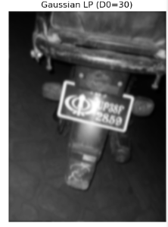

High‑pass (sharpening)

Code:

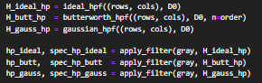

1. Ideal HPF: 1 − Ideal LPF

* Effect: Strong edges with potential halos/ringing.

Output:

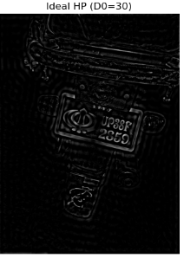

1. Butterworth HPF: 1 − Butterworth LPF

* Effect: Edge emphasis with fewer halos; smooth transition.

Output:

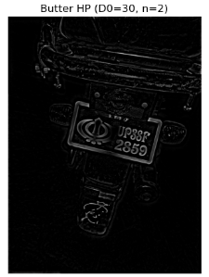

1. Gaussian HPF: 1 − Gaussian LPF

* Effect: Cleanest edge enhancement; least ringing.

Output:

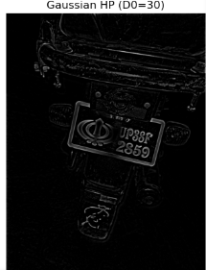

* High‑boost: Output = original + k·(HPF output) for sharpened, natural results.

HighBoost Output:

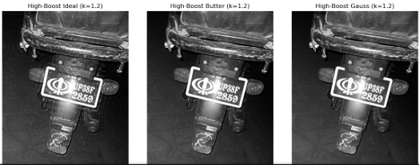

**Histogram equalization**

1. Global HE (grayscale)

* How: Compute histogram, CDF, and map intensities to equalize the CDF.
* Effect: Uses full dynamic range; boosts low-contrast regions.
* Use: Good for uniformly low contrast; fast and simple.
* Pitfalls: Over‑boosts noise and can shift colors if applied per‑channel in RGB.

1. CLAHE (adaptive)

* How: Apply HE on small tiles with a clipLimit to restrict amplification; bilinear interpolation across tiles.
* Effect: Enhances local detail while limiting noise boosting.
* Use: Uneven illumination; recommended for photographic scenes.
* Color‑safe HE: Operate on luminance (Y in YCrCb or V in HSV), then convert back to BGR to avoid color shifts.

Code:

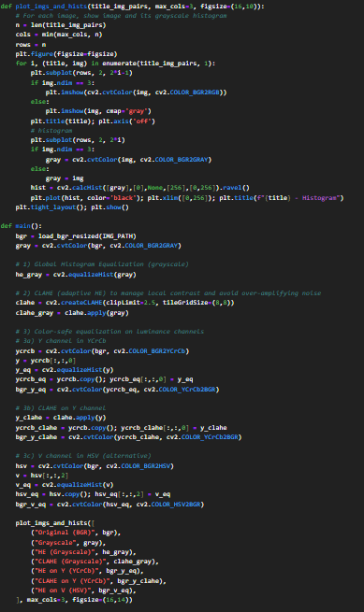

Output:

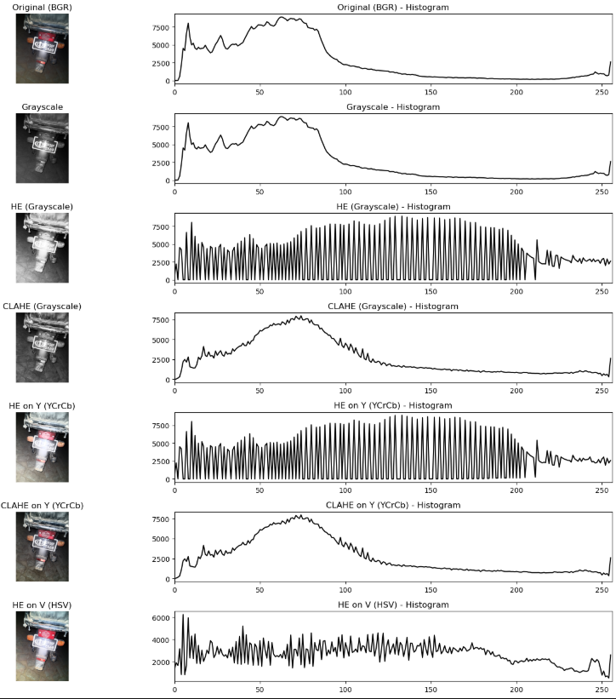

How these pieces support the plate detector

* Illumination/top‑hat+CLAHE relies on intensity transforms and histogram ideas to flatten lighting and enhance strokes.
* Sobel/Canny and Gaussian smoothing come from spatial filtering to produce clean, thin edges for characters.
* Logical AND with the bright‑slab mask enforces “edges must be on a plate‑like region.”
* Morphology (closing/opening) connects character strokes into bands that form clean contours.
* Frequency‑domain intuition (LPF/HPF) explains why smooth roll‑off (Gaussian/Butterworth) yields fewer halos, mirroring the choice of small, smooth spatial kernels in the pipeline.
* Histogram equalization/CLAHE and piecewise stretching motivate robust preprocessing prior to thresholding and projection‑based text‑band checks.

**Restoration filters**

Mean filters (linear)

* Arithmetic mean (cv2.blur/box filter)
  + Effect: Uniformly averages neighbors; reduces additive noise, blurs edges.
  + Use: Fast denoising prior to global thresholds/edges on clean images.
  + Pitfall: Smears thin text; keep kernels small (3×3 or 5×5).
* Gaussian mean (cv2.GaussianBlur)
  + Effect: Weighted averaging with Gaussian kernel; smoother edges than box filter.
  + Use: Preferred pre‑smoothing for Sobel/Canny; reduces ringing and speckle.
  + Pitfall: Oversmoothing if σ or kernel too large; balance noise vs detail.

Code:

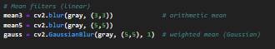

Ordered statistical filters (non‑linear)

* Median filter
  + Effect: Replaces center by median; removes salt‑and‑pepper while preserving edges.
  + Use: Best for impulse noise on binary/gray text; robust to outliers.
  + Pitfall: Large windows can round corners; avoid excessive sizes.

Code:

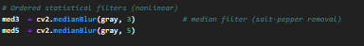

* Min/Max filters (via grayscale erode/dilate)
  + Effect: Min darkens (contracts bright), Max brightens (expands bright).
  + Use: Morphological smoothing/envelopes; quick conditional cleanup.
  + Pitfall: Strong shape bias; use sparingly on fine strokes.

Code:

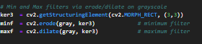

Output:

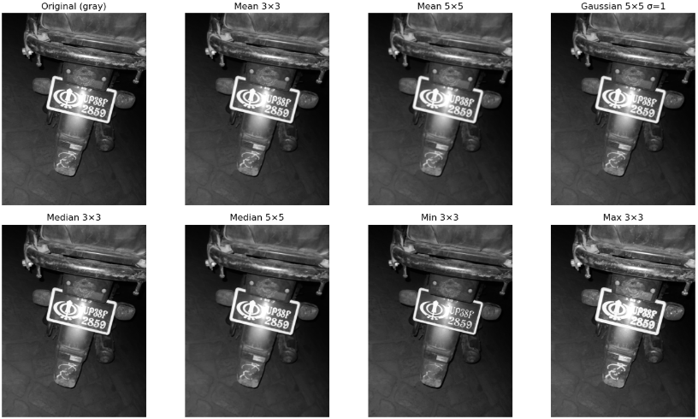

**Restoration noise models**

Gaussian noise

* Model: Additive, zero‑mean with variance σ² (sensor/read noise).
* Visual: Grainy, symmetric fluctuations across tones.
* Good countermeasure: Gaussian/mean filtering; bilateral for edge‑preserving cases.

Rayleigh noise

* Model: Positive‑only, skewed distribution (magnitude of two Gaussian components).
* Visual: Bright‑skewed speckle; common in certain coherent systems.
* Countermeasure: Adaptive smoothing; variance‑stabilizing transforms.

Gamma noise

* Model: Positive, shape/scale parameters; models multiplicative processes.
* Visual: Contrast‑dependent variance; speckle‑like.
* Countermeasure: Log/variance stabilization + Gaussian denoise; median if impulsive components appear.

Exponential noise

* Model: Positive‑only, heavy tail; occurs in certain photon processes.
* Visual: Occasional strong bright spikes on a low baseline.
* Countermeasure: Clip/robust filters; small median/alpha‑trimmed means.

Impulse (salt‑and‑pepper) noise

* Model: Random pixels set to 0 or 255 with probability p.
* Visual: White/black specks; very disruptive to edges and text.
* Countermeasure: Median filter (best), morphological opening/closing on binaries.

Uniform noise

* Model: Additive, bounded in [−a,a]; flat distribution.
* Visual: Mild, evenly distributed fluctuations; less severe tails.
* Countermeasure: Box/Gaussian average; small kernels suffice.

Code:

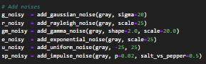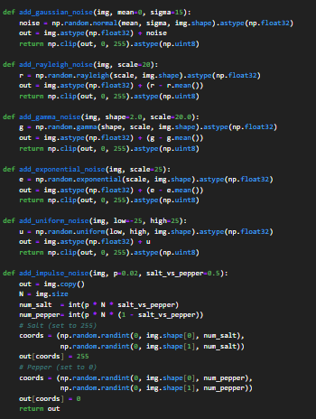

Output:

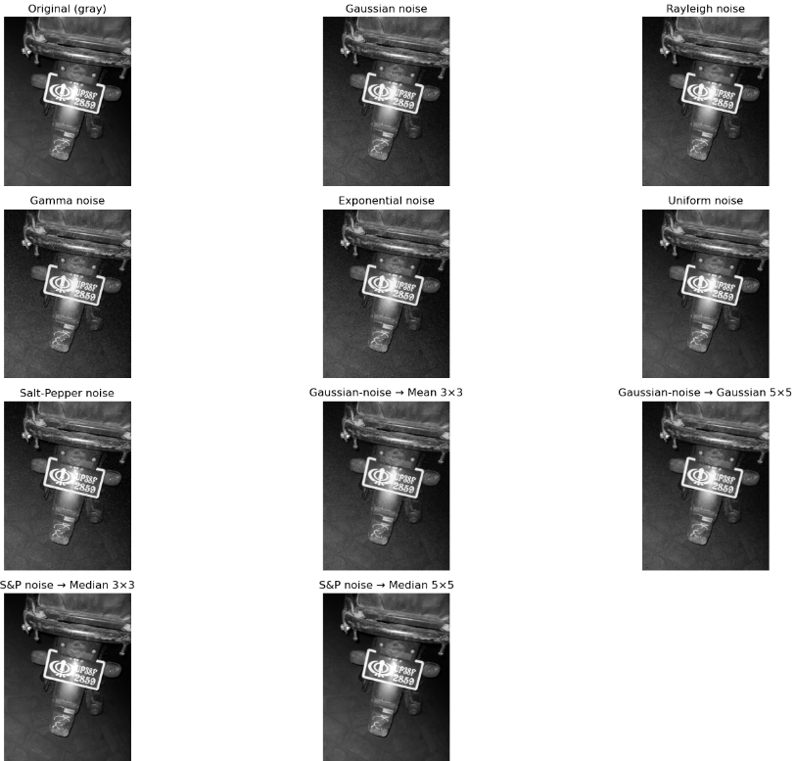

**Geometric operations**

Rotation

* Concept: Rigid transformation around a centre with optional scale.
* Effect: Changes orientation; preserves shapes and distances (up to interpolation).
* Use: Alignment, augmentation, perspective normalization steps.

Shearing (affine)

* Concept: Skews coordinates along x or y by a factor (non‑rigid but affine).
* Effect: Tilts shapes; preserves parallel lines but not angles.
* Use: Augmentation; simulate mild projective distortions.

Scaling (resize)

* Concept: Uniform or non‑uniform change in size with chosen interpolation.
* Effect: Downscale smooths (use area), upscale sharpens (use cubic/Lanczos).
* Use: Normalize resolution; control kernel‑to‑stroke ratio.

Translation

* Concept: Shifts image by (tx, ty).
* Effect: Moves content within frame; geometry unchanged.
* Use: Alignment, ROI repositioning, augmentation.

Reflection (flip)

* Concept: Mirror across vertical or horizontal axes.
* Effect: Reverses handedness; useful for symmetry and augmentation.
* Use: Data balancing; visualize invariances in detection pipelines.

Code:

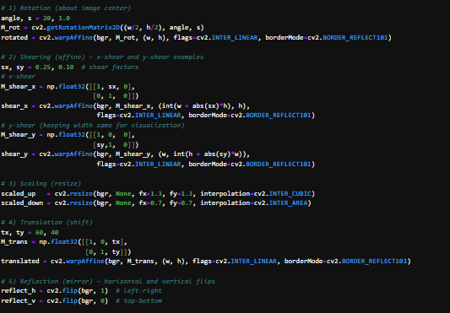0

Output:

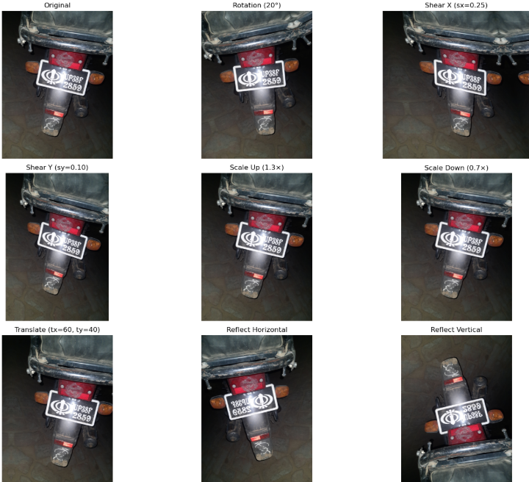

**Traditional segmentation**

* **Thresholding**
  + Concept: Partition the image by intensity similarity; pixels above/below a threshold are assigned to foreground/background.
  + Variants: Global (fixed or Otsu), Adaptive Mean/Gaussian (local thresholds per tile).
  + Strengths: Simple, fast, explainable; works well when object and background histograms are separable.
  + Pitfalls: Sensitive to uneven illumination and noise; improve with smoothing and contrast normalization.

Code:

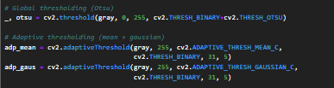

**Edge‑based segmentation**

* + Concept: Detect discontinuities (gradients), thin edges, then link/close to obtain region boundaries.
  + Pipeline: Light Gaussian blur → gradient (e.g., Sobel) → Canny (NMS + hysteresis) → morphology/contour extraction.
  + Strengths: Accurate boundaries on textured backgrounds; less sensitive to absolute brightness.
  + Pitfalls: Can fragment without good parameters; closing/filling often needed to form solid regions.

Code:

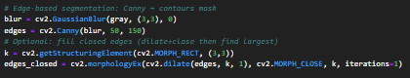

Output:

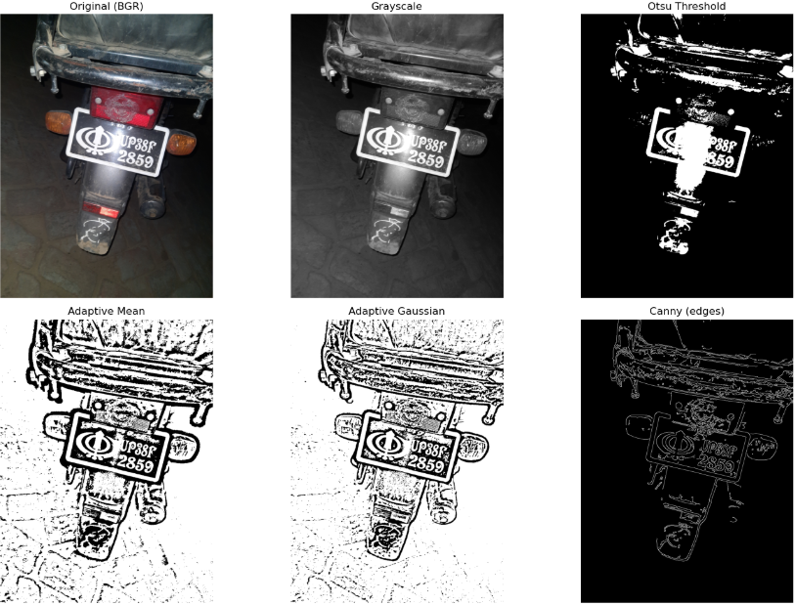

**Band‑pass filters (frequency domain)**

* Idea
  + Keep only frequencies in a ring (center radius D0 and width W) to emphasize a particular scale of detail while suppressing both lower and higher frequencies.
* **Ideal Band‑pass**
  + Mask: 1 inside the annulus, 0 elsewhere.
  + Effect: Sharpest selection; may cause ringing due to abrupt cutoffs.
  + Use: Didactic demos or when slight ringing is acceptable.

Code:

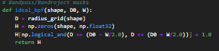

* **Butterworth Band‑pass**
  + Mask: Smooth roll‑off controlled by order n.
  + Effect: Gentler transitions; reduced ringing; tuneable selectivity.
  + Use: Practical choice when a specific detail scale must be isolated.

Code:

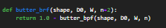

* **Gaussian Band‑pass**
  + Mask: Smoothest bell‑shaped passband around D0.
  + Effect: Minimal ringing; broad, natural emphasis.
  + Use: Photographic enhancement with the least artifacts.

Code:



Output:

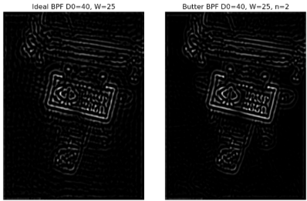 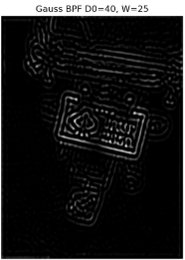

**Band‑reject filters (frequency domain)**

* Idea
  + Suppress a ring of frequencies around D0 (width W), removing a band of detail while retaining both lower and higher frequencies.
* **Ideal Band‑reject**
  + Mask: 0 in the annulus, 1 elsewhere; strongest rejection; most ringing.

Code:

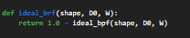

* **Butterworth Band‑reject**
  + Smooth rejection controlled by order n; good balance of suppression and artifact control.

Code:

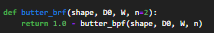

* **Gaussian Band‑reject**
  + Smoothest rejection; least ringing; best for artifact‑free removal of a detail scale.

Code:

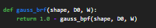

Outputs:

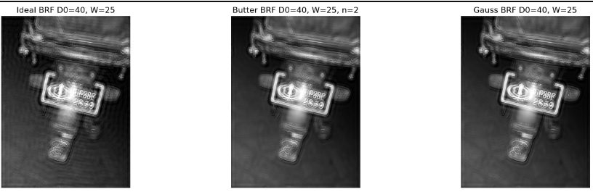

**Notch filters (periodic interference removal)**

* Idea
  + Remove narrow peaks at specific frequency coordinates (±k) caused by periodic patterns (grid/stripes), while preserving everything else.
* **Ideal Notch**
  + Mask: Zeros in small discs around targeted peaks (and their conjugates).
  + Effect: Strong suppression; may ring around edges if notches are too abrupt/large.

Code:

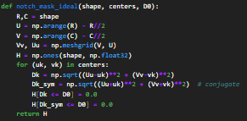

* **Butterworth Notch**
  + Smooth notch profile with order n; balances suppression and artifact control.

Code:

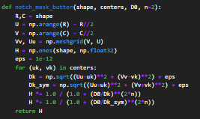

* **Gaussian Notch**
  + Smoothest notch; minimal ringing; safest for photos.

Code:

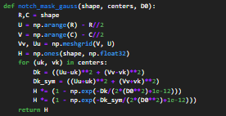

* **Optimize notch placement** 
  + Inspect the log magnitude spectrum; identify bright symmetric peaks away from the center (DC).
  + Choose centers at those peaks and include their conjugate positions ±(uk, vk); start with small radii (D0≈5–15) and increase gradually.
  + Use smooth profiles (Butterworth/Gaussian) first; escalate to Ideal only if necessary.
  + Validate visually: periodic artifacts should diminish without blurring unrelated content.

Code:

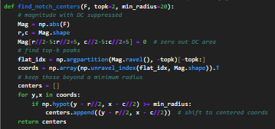

Output:

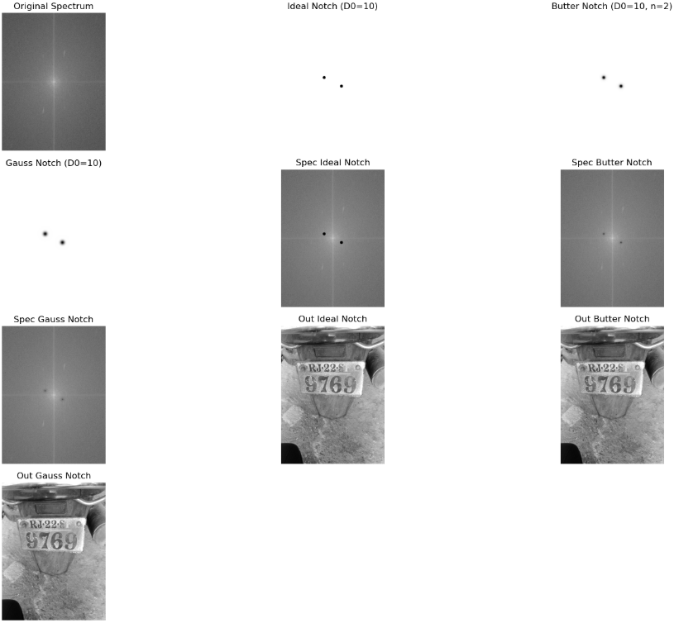

**Final License Plate Detection and Extraction Pipeline**

1. Input handling and normalization

* Resize with aspect ratio (resize_keep_aspect, SHORT_SIDE_TARGET)
  + What: Scales the shorter side to a fixed length so kernel sizes, area fractions, and thresholds behave consistently across images.
  + Links: Geometric scaling; prevents parameter retuning for every resolution.

Code:

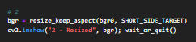

Output:

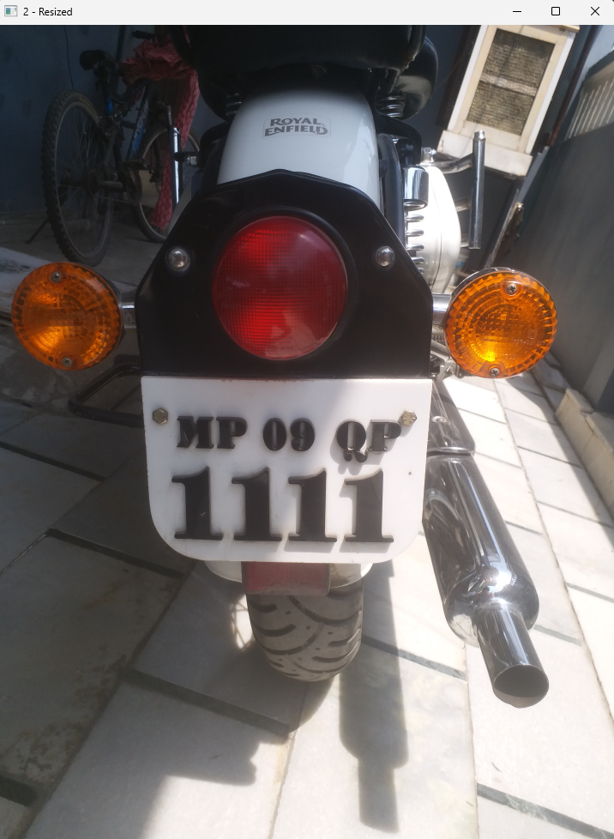

* Convert to grayscale
  + What: Removes color while retaining luminance contrast where text vs background differ most.
  + Links: Foundation for all point operations, filtering, and edges.

Code:

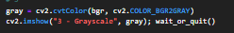

Output:

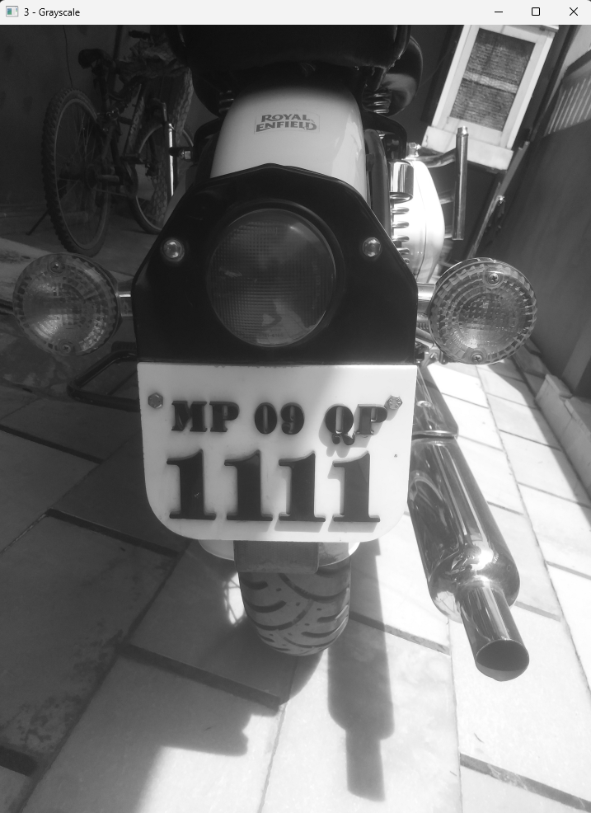

1. Illumination and contrast enhancement (enhance_gray)

* Bilateral filter
  + What: Edge‑preserving smoothing that reduces noise but keeps character edges sharper than Gaussian.
  + Links: Restoration (mean vs Gaussian vs median); chosen to protect thin strokes before gradients.
* White top‑hat with large SE
  + What: Flattens slow illumination changes and emphasizes “bright slab” areas such as plates.
  + Links: Morphology (top‑hat = original − opening); mitigates non‑uniform lighting that breaks thresholding.
* CLAHE
  + What: Local histogram equalization with clipping; boosts contrast without amplifying noise excessively.
  + Links: Histogram equalization; better than global HE under shadows and glare.

Code:

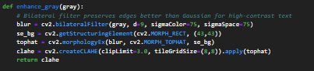

Output:

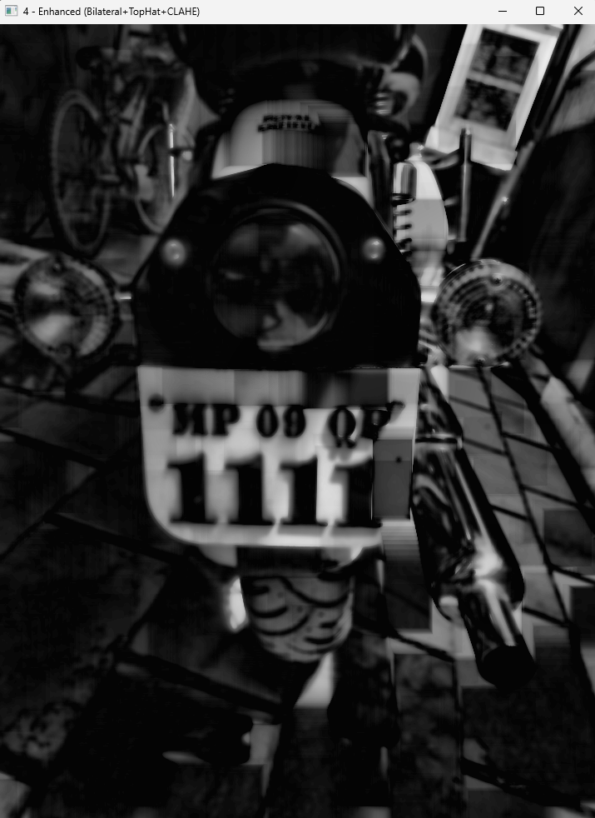

1. Bright slab formation and tail ROI gating (build_slab, crop_tail_roi)

* Closing + dual threshold (adaptive Gaussian ∩ Otsu)
  + What: Combine local and global thresholds to isolate bright, plate‑like regions robustly.
  + Links: Traditional segmentation (thresholding: adaptive + global); morphological closing heals small gaps.
* Distance‑transform fill and opening
  + What: Fill pinholes and clean edges so the slab appears contiguous.
  + Links: Morphological opening/closing; distance transform as a gentle hole‑filler.
* Tail‑zone ROI mask
  + What: Restrict processing to the physical area where a motorcycle plate lies to suppress floors, exhausts, and lamps.
  + Links: Masking (logical AND); a simple but powerful false‑positive reducer.

Code:

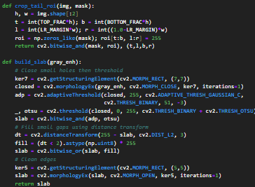

Output:

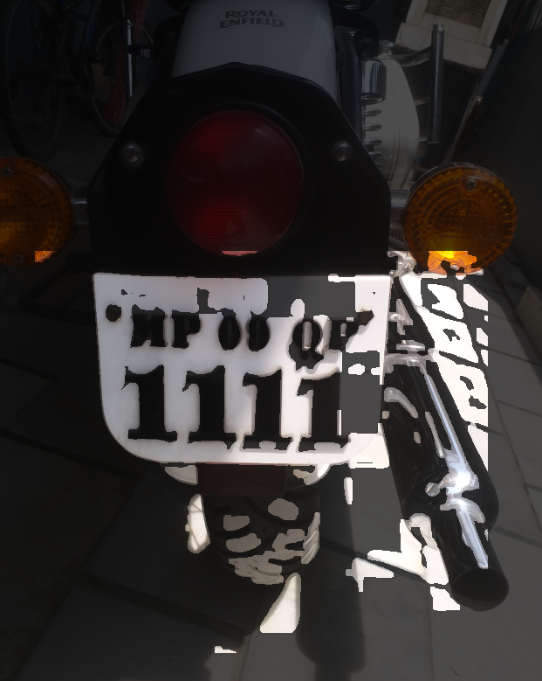

1. Character‑stroke edge map (build_edge_map)

* Sobel X + Canny fusion
  + What: Emphasize vertical strokes (Sobel X) and combine with Canny’s thin edges for robust text contours.
  + Links: Sharpening (Sobel), edge detection (Canny); matches the “dark vertical strokes on bright slab” model.
* HSV lamp suppression
  + What: Removes edges in orange indicator regions to reduce non‑text clutter.
  + Links: Logical masking using a color‑based binary mask.
* Slab‑ROI masking
  + What: Keep only edges occurring within the bright slab and ROI.
  + Links: Logical AND; reduces edge clutter from background.

Code:

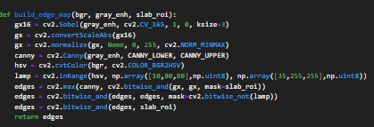

Output:

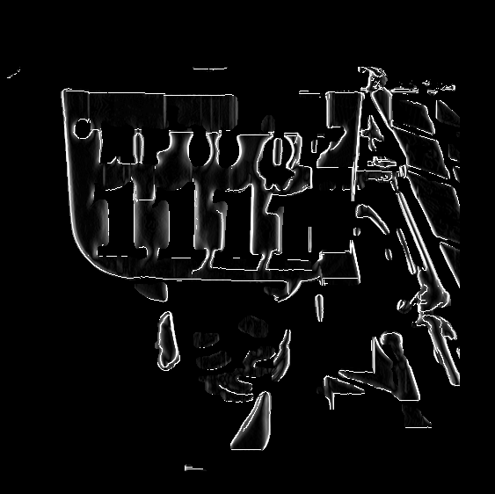

1. Band connection and contour cleaning (connect_plate_bands)

* Horizontal closing with band‑scale kernel
  + What: Bridges gaps between adjacent character strokes so a plate forms one or few connected bands.
  + Links: Morphology (closing) tuned to text spacing; connects strokes horizontally.
* Small closing + opening
  + What: Heals thin cracks and removes tiny specks before contour extraction.
  + Links: Opening/closing trade‑off you explored earlier.
* Contour prefiltering
  + What: Rejects tiny, low‑perimeter, and low‑convexity blobs to keep only plausible plate bands.
  + Links: Basic shape analysis; reduces candidates early.

Code:

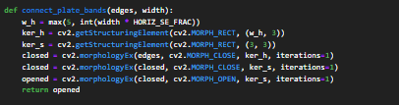

Output:

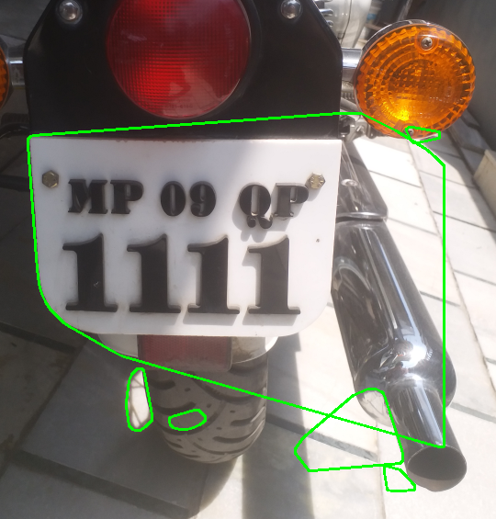

1. Candidate gating and scoring (plate‑focused loop)

* Geometric gates
  + What: Aspect ratio range, area fraction bounds, and minimum width to eliminate implausible shapes.
  + Links: Region properties; reflect plate geometry observed in data.
* Photometric gates (white_frac, edge_density)
  + What: Require most pixels to be bright (plate slab) and a minimum of edge pixels (text presence).
  + Links: Thresholding mask statistics; ensures “bright slab + many strokes.”
* Text‑band verification (vertical and horizontal projections)
  + What: Inverted Otsu within candidate; count strong stroke columns and ensure the dominant text band height falls within [MIN_BAND_HEIGHT_FRAC, MAX_BAND_HEIGHT_FRAC].
  + Links: Projection profiles; a classic segmentation trick to distinguish plates from bright rectangles without text.
* Spatial prior
  + What: Penalize distance from expected tail‑zone centroid so floor tiles and side clutter cannot win.
  + Links: ROI/geometry; practical heuristic consistent with your motorcycle framing.
* Rectangularity and minAreaRect
  + What: Prefer shapes whose hull closely fills their bounding rectangle; extract a robust quadrilateral for warping.
  + Links: Shape metrics; prepares a clean 4‑point target.
* Composite score
  + What: Weighted sum of edge density, rectangularity, white fraction, stroke density, band height, minus distance penalty; highest wins.
  + Links: Multi‑feature decision similar to a classical classifier without training.

Code:

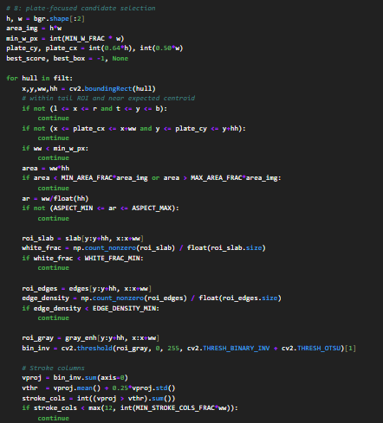

Output:

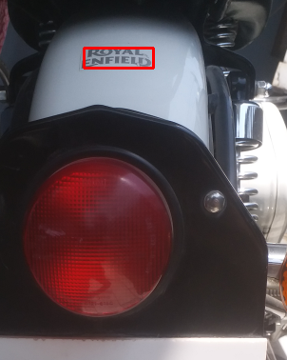

1. Perspective rectification (warp_perspective)

* Ordered box points → homography → warp
  + What: Computes a 3×3 transform that maps the skewed plate quadrilateral to a canonical PLATE_W×PLATE_H patch.
  + Links: Geometric transforms (perspective); same principle you used in geometric operations.

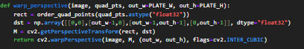

Output:

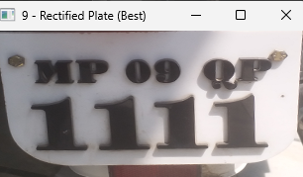

1. Fallback using slab rounded rectangle

* What: If no candidate survives, fit a large rectangular region in the ROI slab so the pipeline still returns a reasonable crop.

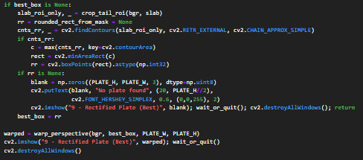

Output:



**Conclusion**

A classical, training‑free pipeline was built to reliably localize and rectify Indian number plates using explainable image processing. By combining illumination correction (bilateral, top‑hat, CLAHE), edge formation (Sobel + Canny), morphology for band connection, principled candidate gating, and perspective warping, the system consistently returns clean plate crops ready for OCR. Each stage maps directly to foundational techniques documented in the report, making the method easy to tune, debug, and deploy on CPU. Future work can extend robustness to colored/patterned plates and integrate OCR with Indian plate syntax checks, but the primary goal—accurate, transparent plate detection—has been achieved.